ST. PATRICK KIGULU GIRLS’ BOARDING PRIMARY SCHOOL
REVISION EXERCISE
P. 1 LITERACY 2020
Name: ____________________________________________
Date: ______________________________________________
- __________________________ is a place where I live.
- Give one domestic animal _______________________
- Name any two basic needs of people.
_______________________ _____________________
- Why is a doctor important?
_________________________________________________
- What are ears used for?
_________________________________________________
- Draw these means of road transport.
car | bus

- Match correctly.
Kitchen chairs
Bedroom basin
Sitting room cups
Bathroom bed
- Draw and name any three things used to keep our bodies clean.
- Why is a broom important in the classroom?
_________________________________________________
- Name three important people found in our community.
- __________________________________________
- __________________________________________
- __________________________________________
(thieves, teachers, murders, doctors, policemen)
- List down any two members of an extended family.
- ______________________ b) _____________________

- What do you call the mother of your father?
_________________________________________________
- Why do we need a hospital in our community?
_________________________________________________
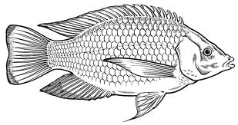

- Name the picture above.
_____________________________________________
- Where does it live?
______________________________________________
- How does it move?
______________________________________________
- Why is a school sign post important to the school?
_________________________________________________
- Write down the young ones of the following animals.
- cow ____________________________________
- goat ____________________________________
- lion _____________________________________
- hen _____________________________________
(kid, cub, chick, calf)
- List down any three important places in our community.
- ___________________________________
- ___________________________________
- ___________________________________
- A group of people living and working together is a __________________________ (school, community)
- Write down two uses of domestic animals.
- _________________________________________________
- _________________________________________________
- Name these domestic animals.
 |  | 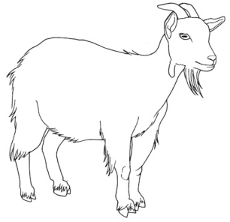
- a) What does a mechanic do? (cooks food, repairs cars)
_______________________________________________________

- Why is a market important in our community?
__________________________________________________________________________________________________________
- What do you call the place where we keep our money? (shop, bank)
_______________________________________________

- Look at the arm and name the parts a, b and c.
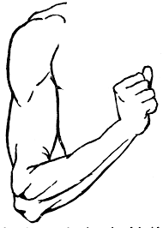
- _____________________
- _____________________
- _____________________

23. Mention four things found in the classroom.
a) _______________________ (b) ______________________
c) _______________________ (d) ______________________
24. Which item is used to clean the chalkboard?
____________________________________________________

